**Marketing Campaign**  
We are about to start a marketing campaign for products and services - this might be by product area, using mailchimp, primarily to those in FES. 7/27/15 have set up separate marketing computer with all the tools ready to go. We are likely to hire admin assistant in coming weeks, who might be virtual, to log on and start work. 8/3/15 will post R&Rs to craigslist later today for admin assist. 8/17/15 as with all scientific activities, best marketing is done at conferences!  Will be sending out appropriate information in the coming weeks since we now have a full list of APS abstracts.  Hiring someone this week (we had an overwhelming response to the CL posting**).**8/31/15 have offered job to one virtual assistant.  9/8/15 Felicia Edwards onboard ([Felicia@woodruffscientific.com](mailto:Felicia@woodruffscientific.com)) who now has responsibility for getting the lists and campaign information together. 9/21/15 need to get cracking generating content and lists - likely a few each week**.**9/28/15 still generating lists, and content for email campaign prior to APS. 10/5/15 more names added to the list - we will target the big few institutions initially and get information to them, content to be discussed. 10/19/15 Felicia has done a great job getting information together for marketing... will populate website next week with EDR information for diagnostics, and send a pre-APS mailer letting folk know what we are doing (APS abstracts, some nice figures, a few sentences about various projects ongoing). 11/2/15 lists almost done for outreach - likely by end of the week when we have finished with website updates. 11/9/15 Wednesday, website updates are live, so will be ready to send links to wider distribution.   
11/16/15 we are ready for wider distributino, though we have discovered that there are so few people on the list that individual emails are going to be the way to go- perhaps using Felicia's format so we can see who opens it and what they look at!  
11/23  
  
**SBIRs for 2016: Force-free superconductor winding for fusion applications**  
5/4/15 Superconductors are of interest to Tokamak Energy, so they have offered to support some of the work (in emails this weekend).  They need a white paper.  Am exploring with many other orgs how we move these forwards. 5/18/15 writing white paper with STI Optronics, SuperPower Inc and others - Barry Sullivan said that we are welcome to resubmit. 5/25/15 discussed white paper with Paul, will send out asap.6/1/15 white paper 1st draft sent out. 7/6/15 will send out next draft this week. 7/20/15 still working on drafts - need a deadline for these... perhaps the September meeting for CFSI. 7/27/15 no progress. 8/3/15 white paper still needs to get written... will see if there is time this week to push this along. 8/17/15 still on back-burner due to no immediate deadline.8/31/15 still on back burner (likely will visit after APS).9/21/15 will see if we can bolster this at APS. 10/5/15 have been printing force-free forms (3D spirals - will share more as these reach maturity).  
  
  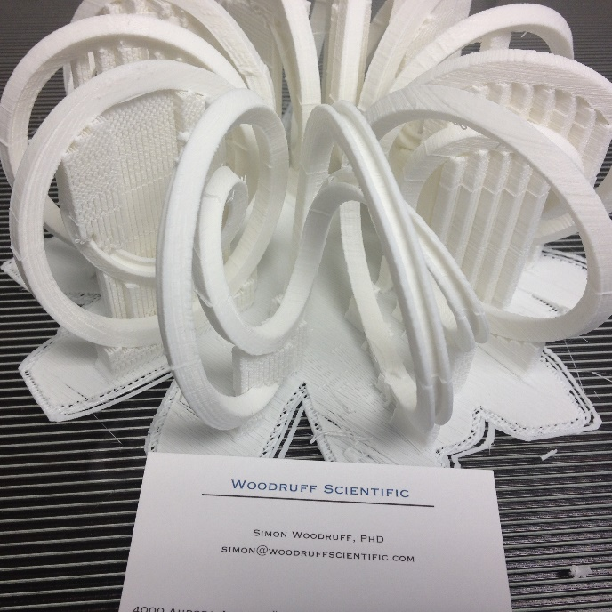  
  
10/19/15 have sent image on to SuperPower Inc.  Perhaps we will get some more accurate information about the tape dimensions for a final prototype before rewriting the proposal.11/2/15 - I broke the 3D printer last week, got new parts in, will print a three layer coil this week. 11/9/15 will retire the printer since turn-around time from shapeways is 5 days.  Higher quality prints with less post-processing from them too.  
**11/16/15 have asked Drew Hazelton from Superpower to collaborate on the resubmittal.  Have asked for dimensions so we can geet a more accurate coil printed.**  
  
**SBIRs for 2016: Validation tool for fusion energy sciences**  
5/4/18 Tri-Alpha expressed interest in the validation tool, so will see how that develops. 6/1/15 nothing from TAE on this. 6/15/15 something we could develop further for Bootcamp. 7/27/15 work towards September meeting for CFSI. 8/3/15 white paper still needs to get written... will see if there is time this week to push this along. 8/17/15 APS abstract on this subject will help re-application.9/8/15 am working on a bootcamp presentation on this subject. 9/21/15 Bootcamp presentations on V&V were useful - will generate some slides on this for APS while it is fresh in my mind. We should be able to do a synthetic PTS and compare with real, which would support the proposal. 10/12/15 an hour long call with LoDestro and Casper last week - was very interesting... would like to find a way to develop CORSICA for the 21st century, but there's a lot to do to make that work.  We talked about 'industry hardening' the code, which may take a rewrite of the wrapper... it might also fit into the context of the validation activity... will see. 10/19/15 will give this some thought this week and in run-up to APS.11/2/15 - NIMROD post-processing/synthetic diagnostics is looking good - will share at APS. 11/9/15 - likely by Friday this week we will have data to share on this subject.  
  
  
**SBIRs for 2016: Liquid metal walls for fusion systems**  
5/18/15 Dick Majeski is thinking about how we move the subject forwards. Brett Chapman had a few ideas, and again Tokamak Energy expressed interest in the subject matter. 6/1/15 first draft of white paper done - need to spend 3 hours or so on the next draft. 7/20/15 work towards September meeting for CFSI. 7/27/15 Richard Nygren visited on Friday and expressed great interest in this concept. 8/3/15 white paper still needs to get written... will see if there is time this week to push this along. 8/17/15 still on backburner. 8/31/15 discussed with Carlos - he has interest in this subject, perhaps do expt at UMBC, modeling at WSI. 10/12/15 have printed a reservoir to do a basic flow test with water.    
  
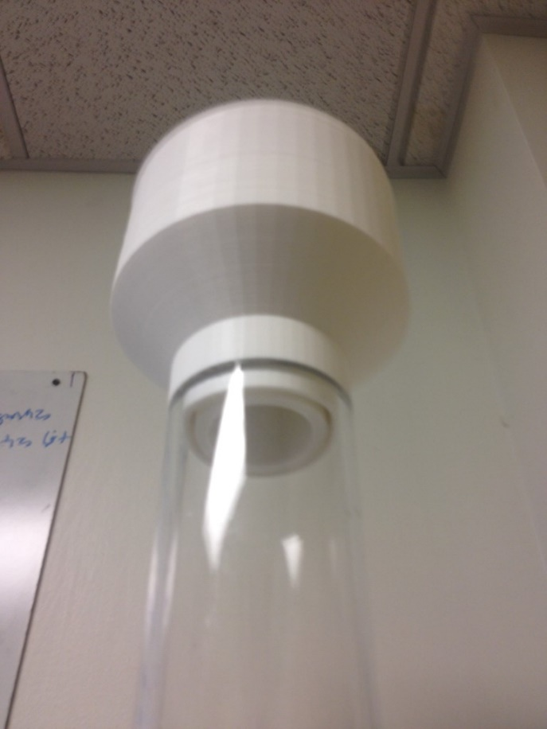  
  
10/19/15 have ordered some rheoscopic fluid and a gallon of glygerin to visualize the flow. 10/24/15 Rheoscopic fluid is in.  Other parts coming.11/2/15 parts in for basic fluid flow experiemtn with 3D printed reservoir. WIll set up this week. 11/9/15 reservoir works with glycerin, but needed a new nozzle - have 3d printed.  More soon in a separate email - have got a symmetric fluid sheet to flow that is 2 mm thick.  
**11/16/15 talking with Dick and Brett tomorrow about reapplicatino.**  
  
  
**SBIRs for 2016 W7X simulations - next deadline Dec 2015**  
decision on W7X proposals due ‘this winter’ (according to Barish).  Submitted an abstract to the IOP meeting in March relating to this, mailed to Pedersen.  Will see if we can move this forwards.  Slava has left NRL now and is at NSF as a program manager, which means we might need to find another collaborator on this. (Alan is collaborating on the Phase I application for the development of a validation tool, although expressed disinterest in stellarators).  2/16/15 have withdrawn abstract from IOP meeting, have pinged Barish again, and he immediately wrote back.  Have sent abstract to Mike Z., Jeff H to ask for advice on moving this line of work forwards. 2/23/15 still nothing. 3/2/15 nada. 3/9/15 declination.  Going to debrief with Sam shortly, see if we can do this directly wtiith w7x. 3/16/15 Thomas Klinger (W7X Director for Research) invited me to visit Greifswald, so will go during UK visit in April. 3/23/15 going to meet Thomas on the 10th April, flying to Berlin then train to Griefswald.  Talking wirh Slava today about finding a HiFi person since he is now at NSF – he suggested Matt Landreman… will see.  4/13/15 turns out Slava submitted competing HiFi proposal with Landreman in the last round.  Landremann quite content for us to take on stellarators.  Geiger reviewing this week. 4/27/15 chat with Geiger went well – set up a call to discuss development of HiFi for stellarators for early June, likely to be submitted as SBIR proposal. 5/4/15 Ware to present HiFi discussion at stellarator workshop in Germany in October, and we have s June 3rd coordinating call. 6/1/15 new DOE call for which this might be a fit: <https://www.fedconnect.net/fedconnect?doc=DE-FOA-0001348&agency=DOE> 6/15/15 talked up with HiFi stellarator 'team' so moving forwards.  Need to send letter to David Anderson and others.  Ron mentioned interest in submitting something along the lines of our FE&D paper aimed at tokamaks.  Would be keen to get that together.  Will look at pre-application requirements today. 7/6/15 after staring at requirements, it didn't seem like a good fit for us in this round. We'll work towards SBIR in Dec. 7/20/15 - how does this fit into the context of moving things forwards?  Perhaps Eric could talk it up, and in particularly in context of his new modeling efforts.7/27/15 Eric Meier visited on Wedensday last week - he's now living in Seattle.  Will try to coax him into more involvement on modeling side of things. 8/17/15 still on back-burner - likely will discuss with all at APS in a HiFi session - will send announcement this week. 9/21/15 have sent first email to HiFi distribution list. 10/5/15 Slava set up distribution list for HiFi related development, so nixing the APS meeting discussion.  10/12/15 Ware visited W7X last week, so will hear back this week. 10/19/15 - in our bootcamp, we ported in the W7X geometry, although we need to convert the file to a single volume for cubit to make a grid from. **10/24/15 anyone that wants to try to make a volume from the surface, Morgan, James, Pauls - the W7X files are on the engineering computer under 'Devices'**  
  
**SBIRs for 2016: Compact fusion neutron source (to Nuclear Physics rather than FES)**  
Eagle Harbor Technologies visited on Friday and discussed their pulser technology.  It would likely be a good collaborative proposal if we can utilize their tech. 7/20/15 requested information from them, but I think it is:<http://www.eagleharbortech.com/products-new/ipm-nanosecond/> 7/27/15 no further progress - Bick asked what our reviews were like last year - they were not good.  8/17/15 seeking collaborators since the call has come out again. 8/31/15 sounds like we have a consortium between EHT and WSI and possibly Decysive... 9/8/15 submitted LOI, deadline for full proposal is Monday, October 19, 2015 11:59pm ET - the proposal exists - I will take a look after the bootcamp and update the contents before inviting collaborators into the mix.  See the LOI [here.](https://gallery.mailchimp.com/f4b64a3a93dfc6088f685111d/files/LOI_summ2016_1.pdf) 9/21/15 need to get first couple of sections written - maybe on flight to SD on Wednesday! 9/28/15 now there are 20 days until the deadline... will generate first sections this week. 14 days until deadline - will send out sections for review this week by all. 10/12/15 7 days until deadline - have invited all, but we need to get this written asap. 10/19/15 submitted - much more substantial proposal this year.11/2/15 - out for review.  Likely will hear by January.  
  
DARPA Intense Compact Neutron Source (ICONS)  
<http://globalbiodefense.com/2014/10/02/darpa-baa-intense-compact-neutron-sources-icons/>  
10/19/15 Will  monitor this call and see if we can get something together with EHT in the next round.  10/24/15 one of Vincent's recent presentations is here:  <https://www.youtube.com/watch?v=qOjenkeKWz8>  
  
  
**Disruption simulations - next deadline May 2016**  
After ITER rejection, debriefed with Mandrekas – he suggested one of his calls might be appropriate if we can develop a stronger Theory component.  Lehnen said he would see if he could send reviews.  Am exploring with Choi, and Izzo and Eidietis at DIII-D.  Likely we will produce a proposal for the May theory call, might need to bolster theory component. 2/16/15 we are still waiting for feedback from Lehnen (have pinged him again today). 2/23/15 got feedback, though sound like this will go to Val.  3/2/15 will need to prep proposal for May theory call**.**3/23/15 might derate this opportunity. 4/2/15 Kara convinced me that  we should be keeping this option open.  Will monitor the FOAs. 4/13/15 Sovinec invited a 2 page white paper on synthetic diagnostics applied to disruption simulations.  Due in two days, will circulate. 4/27/15 Baylor and Rasmussen ready to chat about proposal – likely on the 7th May. LOIs for Theory call are due May 15th.  Eric Meier will join the call.  Anyone else?   5/4/15 Mandrekas is Ok with us sending him the proposal although stresses that Lab employees can’t be written in except as ‘no cost’5/11/15 spoke with Baylor and Rasmussen, and they narrowed the scope so, need to rewrite.  5/18/15 submitted LOI for Theory FOA on 'Development of theory and simulations for disruption mitigation'  deadline is June 30th. 5/25/15 will rewrite the proposal this week and send out to all interested parties.6/1/15 still need to iterate proposal - will set aside a couple of hours this week.  6/15/15 - proposal draft iterated.  To be sent out this week to collaborators. 7/6/15 put on backburner for the time-being.  John said submit it next year if we have avail etc. 7/20/15 No further progress.  8/9/15 will be showing some of this to the Scientific Computing Bootcamp next week. 9/21/15 - perhaps would serve us to get the last set of results published.  9/28/15 visit with Myunghee Choi was good in San Diego - plainly still interest in this.  Have pinged Val and Nick to see if we can get some time with them to discuss.10/5/15 - Val wrote back - still a lot of interest in this discussion, but much more work needed.  10/12/15 perhaps some of this can be supported by Wurden's RE diagnostic proposal have sent sometext, perhaps too late, will see**.**10/24/15 nope not something for Glen's proposal.**11/2/15 - will do the rounds at APS.  
11/16/15 had nice chats with folk from FarTECH, Sergei Galkin - there is a  Phase II application being generated for disruption simulations, or rather a consol-business model for simulation development.  Was nice to see Larry Baylor at my poster too - he has a talk on Thursday in the ITER session, will try to make that one.**